

LAB # 4



COVER PAGE

Timothy Annis

ET-501J1

12/5/16

Lab 4

Creating a Laboratory Report

Prof. Lawerence

**SERIES DC RESISTIVE CIRCUITS**

**OBJECTIVE:** To investigate the characteristics of a series DC resistive circuit.

**EQUIPMENT:**

Resistors 1- 330W

2- 220W

1- 470W

1- 100W

Instruments 1- DMM or VOM

1- dc Power Supply

**RESUME OF THEORY:**

In a series circuit, the current is the same through all of the circuit elements. The total resistance, RT, of a series circuit is the sum of the individual resistance’s. By Ohm's law, the current is equal to the voltage divided by the resistance.

**DIAGRAM:**

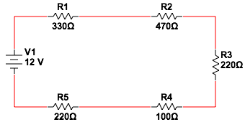

**DATA:**

|  |  |
| --- | --- |
| VOLTAGE (V) | CURRENT (mA) |
| 0 | 0 |
| 10 | 7.5 |
| 20 | 14.9 |
| 40 | 29.9 |
| 50 | 37.3 |

**GRAPH:**

**CALCULATIONS:**

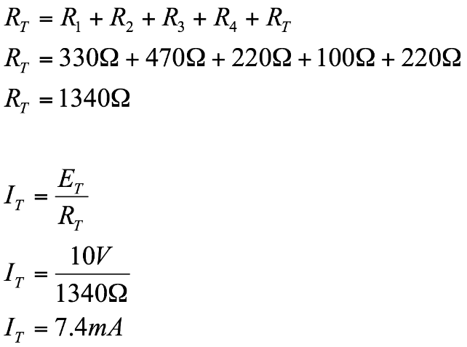

**CONCLUSION:**

From the data collected we saw that in a series circuit, the total resistance RT, is the sum of the individual resistance’s. Furthermore we were able to verify Ohm’s Law, which states that the current is equal to the voltage divided by the resistance. Our calculations and graphs agreed with the theory we learned in class.